COUCHBASE CAPELLA Workshop

**Lab Handbook**

Couchbase Capella UI Walkthrough

# Lab Description

In this section we will do a quick walk through of Couchbase Capella UI and various tabs

# 

# Signing Up:

Go to <https://cloud.couchbase.com/sign-up>

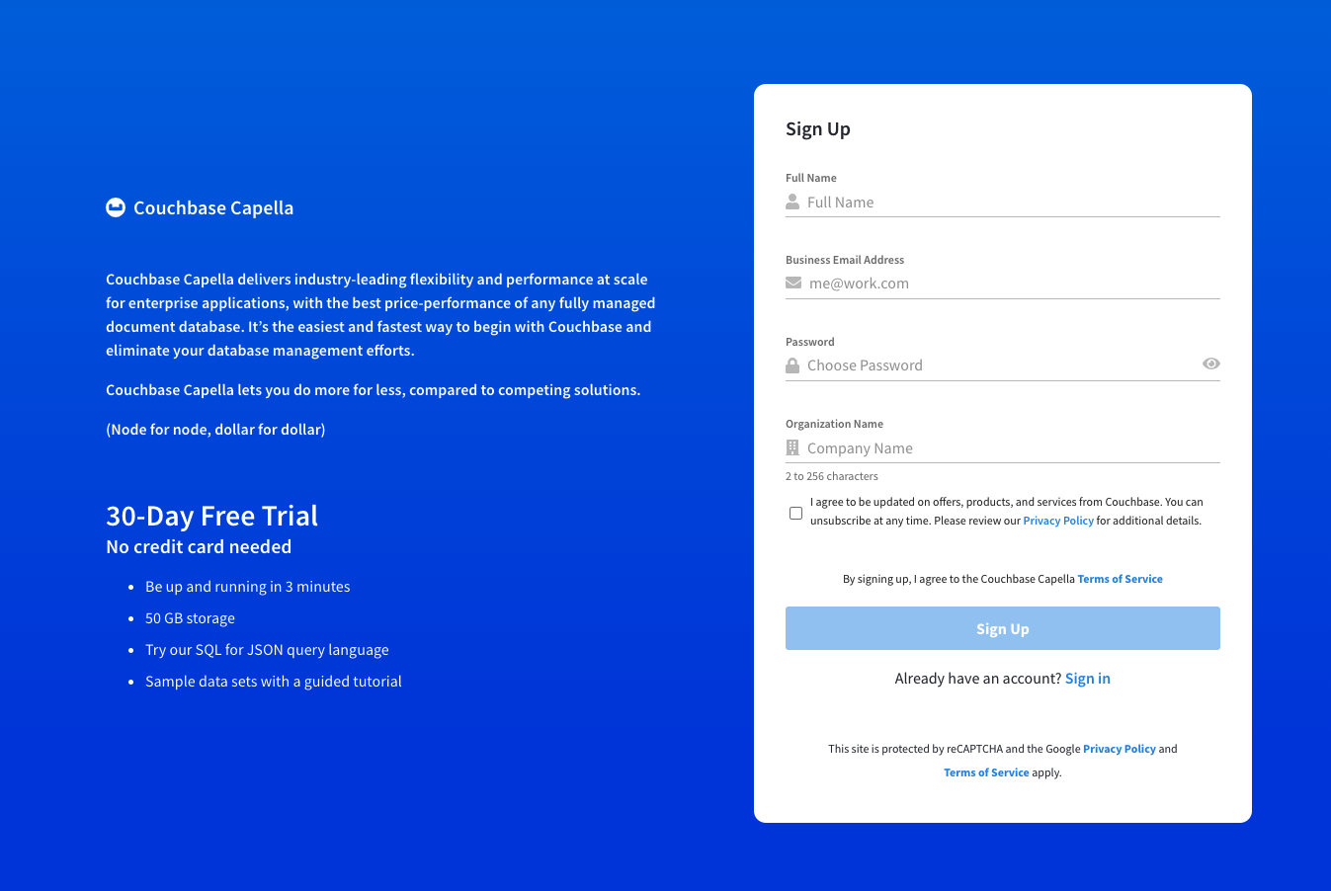

1. Provide your account details. Enter the following information to create your account:
   * Full Name
   * Email Address
   * Organization Name
   * Password

|  | **/!\ Passwords have the following requirements:**   * **Contain at least eight characters** * **Contain uppercase, number, and symbol characters** |
| --- | --- |

1. To be updated on offers, products, and services from Couchbase, review the [Privacy Policy](https://www.couchbase.com/privacy-policy) and click the checkbox.
2. Review the [Terms of Service](https://www.couchbase.com/CapellaCSSA10192021)
3. Click Sign Up to accept the Terms of Service and create your account.
4. Confirm your account.

An email will be sent to you asking you to confirm your email address. Once you click the confirmation link, your account will be confirmed and you’ll be able to sign into Couchbase Capella at [cloud.couchbase.com](https://cloud.couchbase.com/).

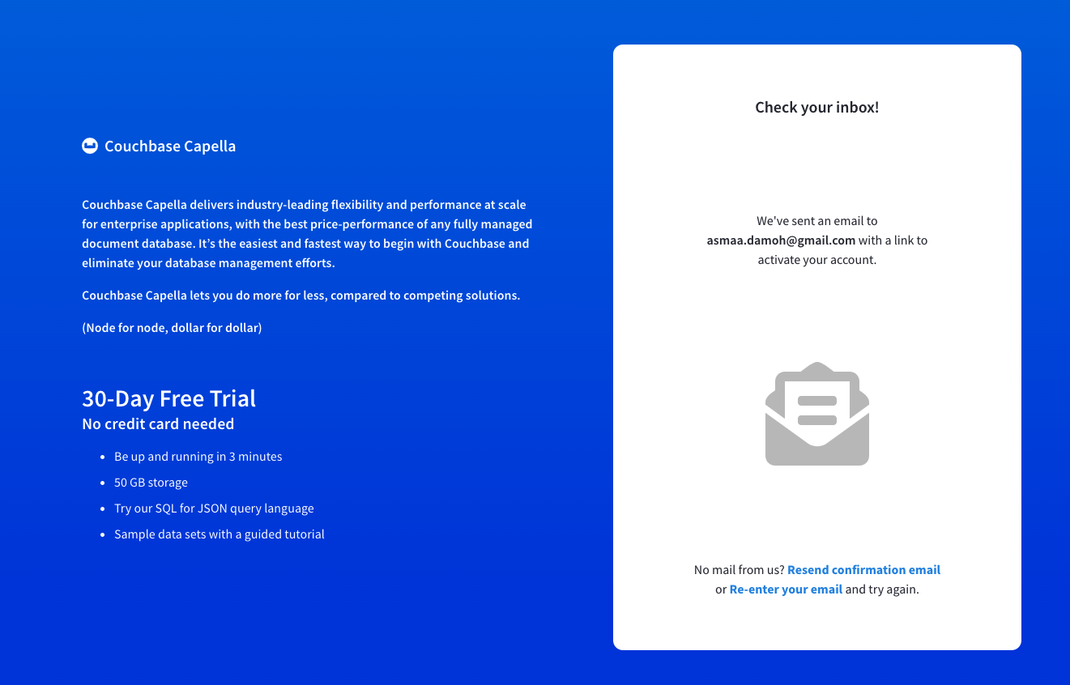

You will receive a confirmation email to validate your account. Your 30-day free trial account includes:

* Access to the most common features ( query, search services)
* 50Gb of storage
* Forum Base support

You can use your own cloud provider with Aws or Azure to deploy your first cluster, but in this Lab we recommend you to use the couchbase’s cloud account.

* Select your region
* Click on Deploy now to create your first couchbase cluster

/!\ The cluster will generally take under 2 minutes to deploy.

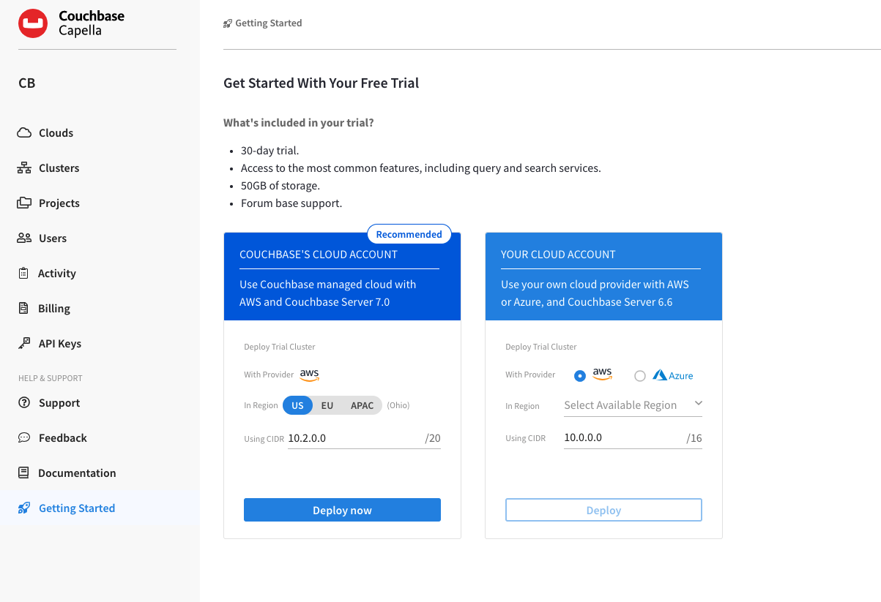

In the middle section, you will see three sections: *Set Up*, *Access*, and *Work With Data*.

* Set Up: Provides a link to the Clusters area, the Welcome Video and this tutorial.
* Access: Provides links to establishing credentials for external database access and the area for setting up allowed IP addresses.
* Work With Data: Links to the sample data import tool.

On the right, you will see three sections: *Cluster Status*, *What’s Next*, and *Want to Know More?*.

* Cluster Status: Links to where you can see all of your database clusters.
* What’s Next: Links to many helpful resources and access to the Capella Forum.
* Want to Know More?: Here you can contact the Couchbase Team.

On the left, you will see the main navigation items, like *Clusters*, *Projects*, and *Users*

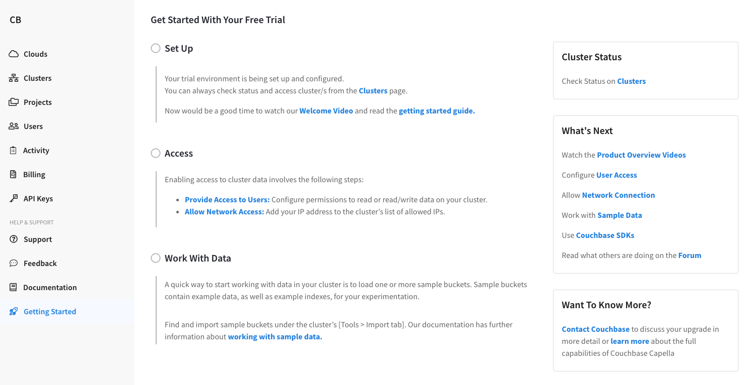

# Projects:

Within organizations, *projects* are used to organize and manage groups of Couchbase clusters. An organization can contain any number of projects, and a project can contain any number of clusters.

A cluster must be contained within a project. When you create a cluster, you’ll be required to select a project for it to be contained in. A cluster can only be contained in a single project, and cannot be shared across multiple projects.

The main purpose of a project is to manage access to a particular set of clusters. Organization users can access the clusters within a project once they have been added as members of the project.

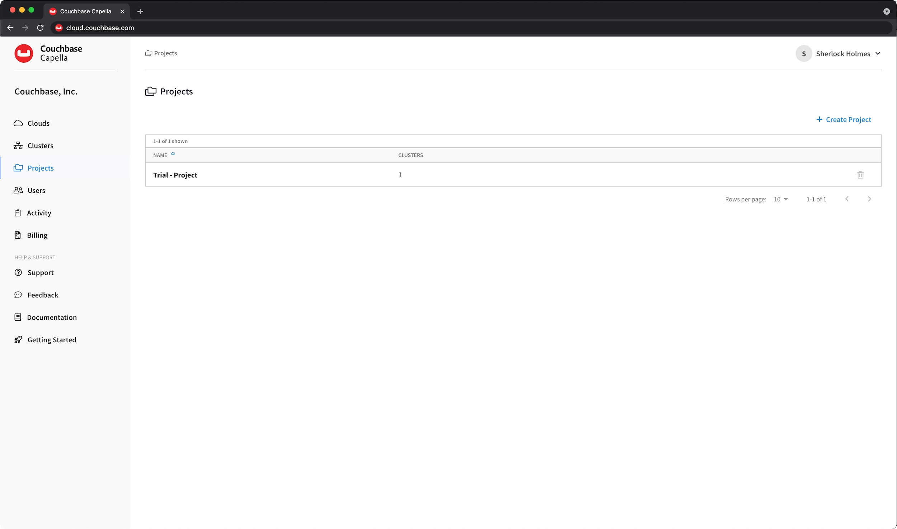

# Clusters:

1. Click on the Projects tab on the left.  
   This will show all the projects for your account. Projects are a great way to link clusters and users together for easier management.
2. Click Trial - Project to open this project.  
   With a project open, you will see a list of all clusters in the project, along with cluster health, cloud provider, and region information for each.
3. Click Trial - Cluster to view the details of this cluster.

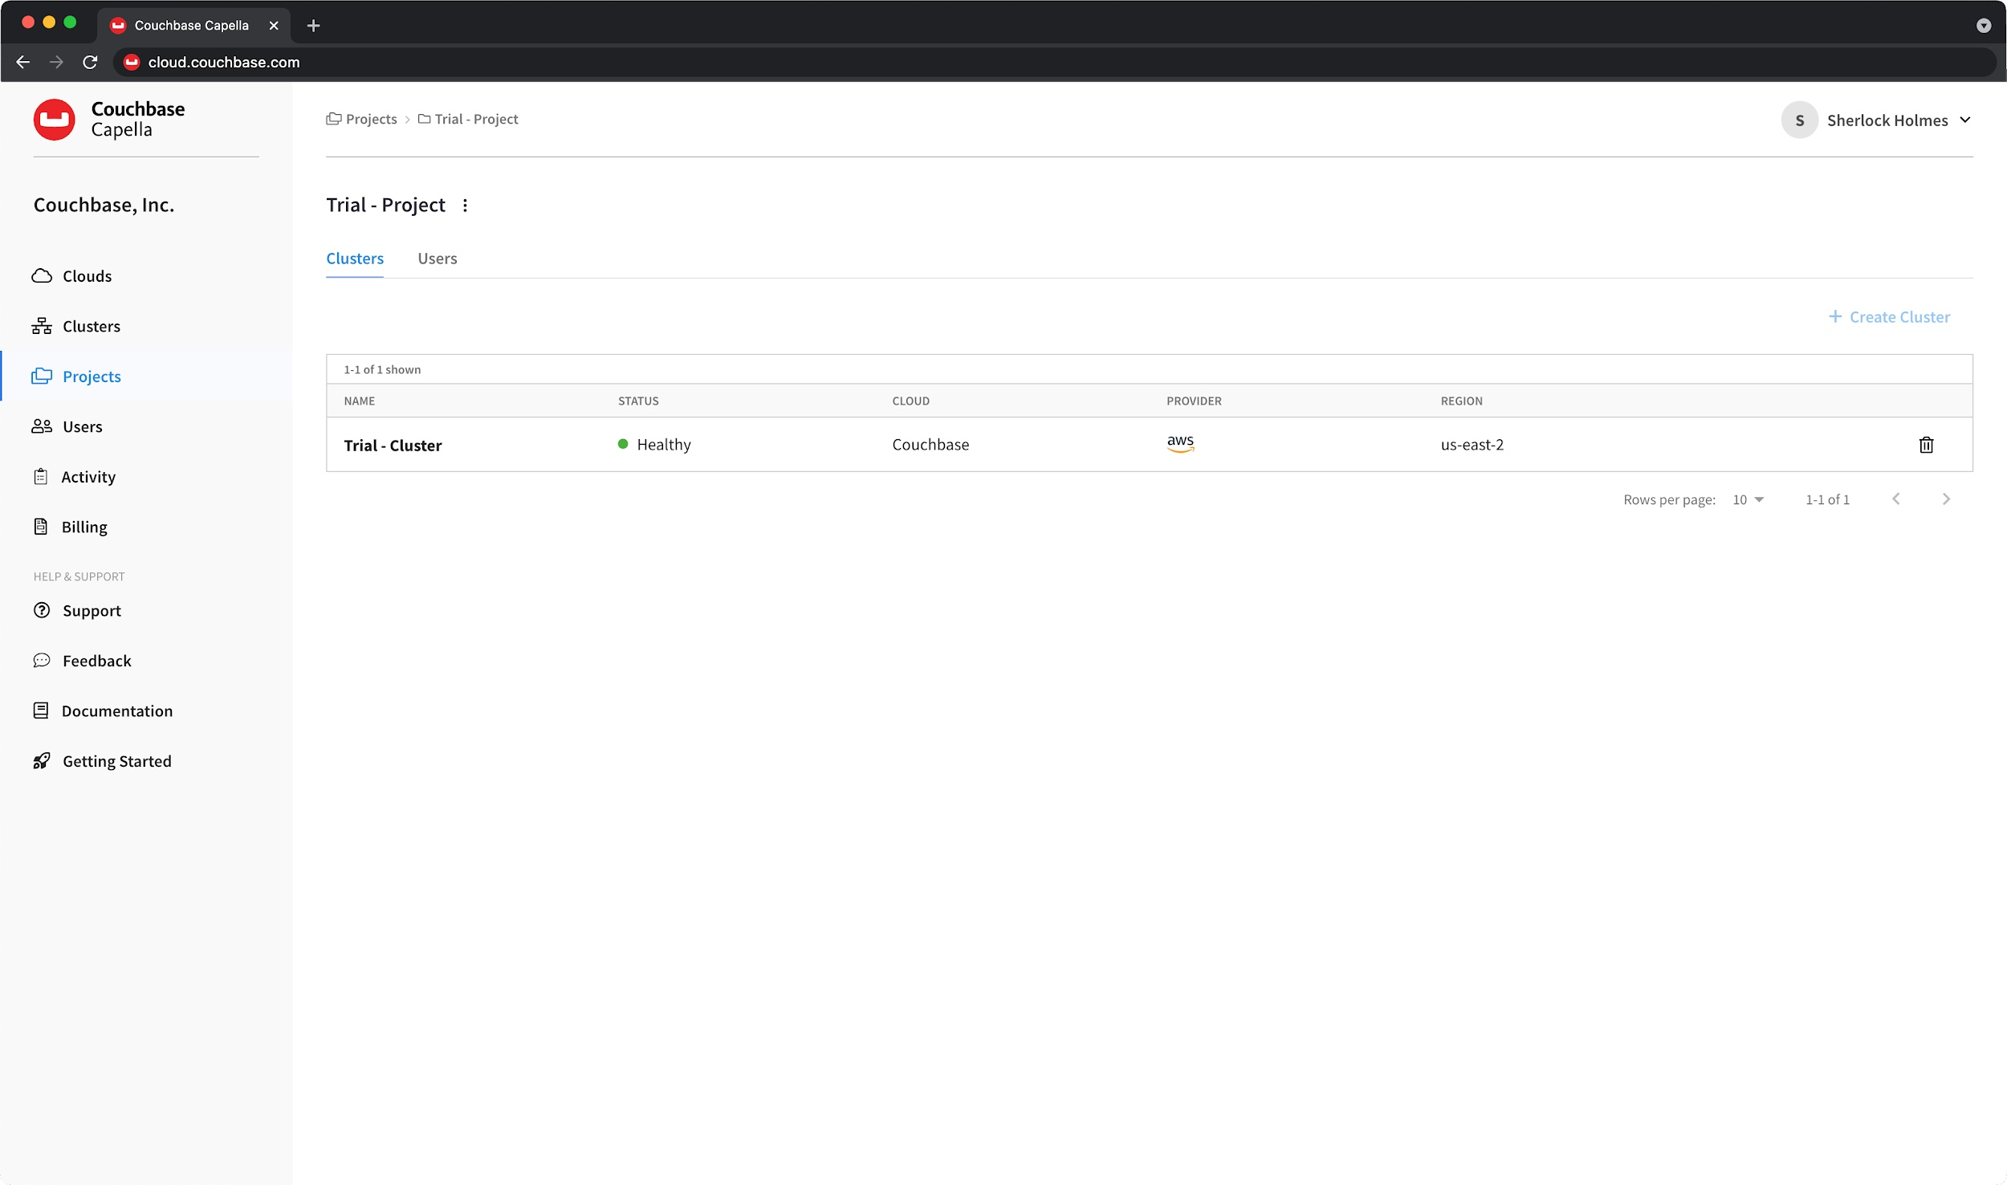

# Metrics:

With the cluster open, you will now see multiple tabs below the cluster name. It will default to Metrics. As this is your first time examining the cluster, no metrics are shown—​let’s add some.

While you can add metrics one-by-one by clicking in the *Add Metrics* area, the easier path is to use the template that is set up with several predefined metrics.

1. Click the blue Data Services link in the middle of the screen.  
   This will add several metrics to your dashboard.

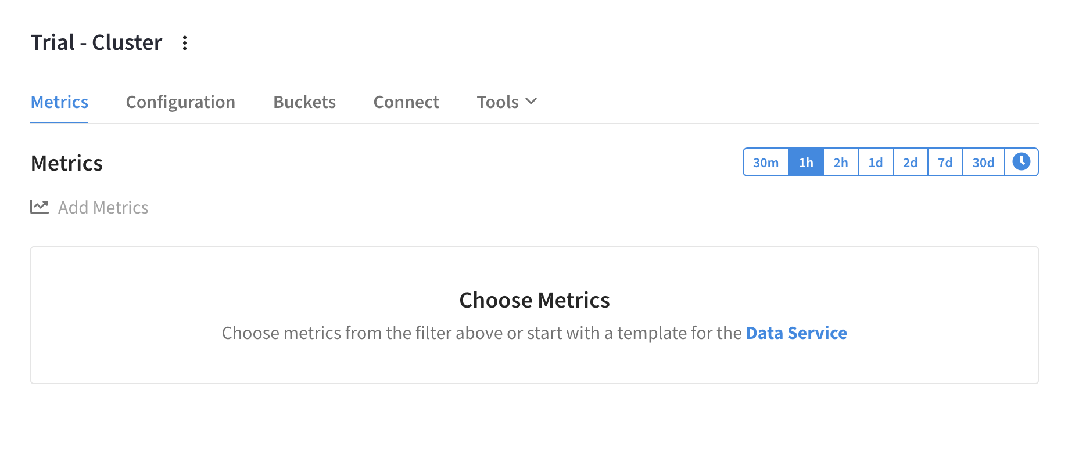

# 

# Users:

The **Users** tab shows a summary of all users that have been added to the organization. The summary is displayed in table format, with sortable columns and a row for each user. A search field is provided at the top of the summary, which you can use to search for any term or value that is listed in the summary table. A checkbox is also provided for quickly filtering the user summary to only show [pending users](https://docs.couchbase.com/cloud/organizations/manage-organization-users.html#view-active-pending-users).

The user summary displays the following information about each user:

* User

The Full Name and Email address of the user. This column is sorted based on Full Name.

* Status

The invitation status of the user: **Verified** or **Pending**.

* Type

The type of user account: **Couchbase Capella** user or **Database** user

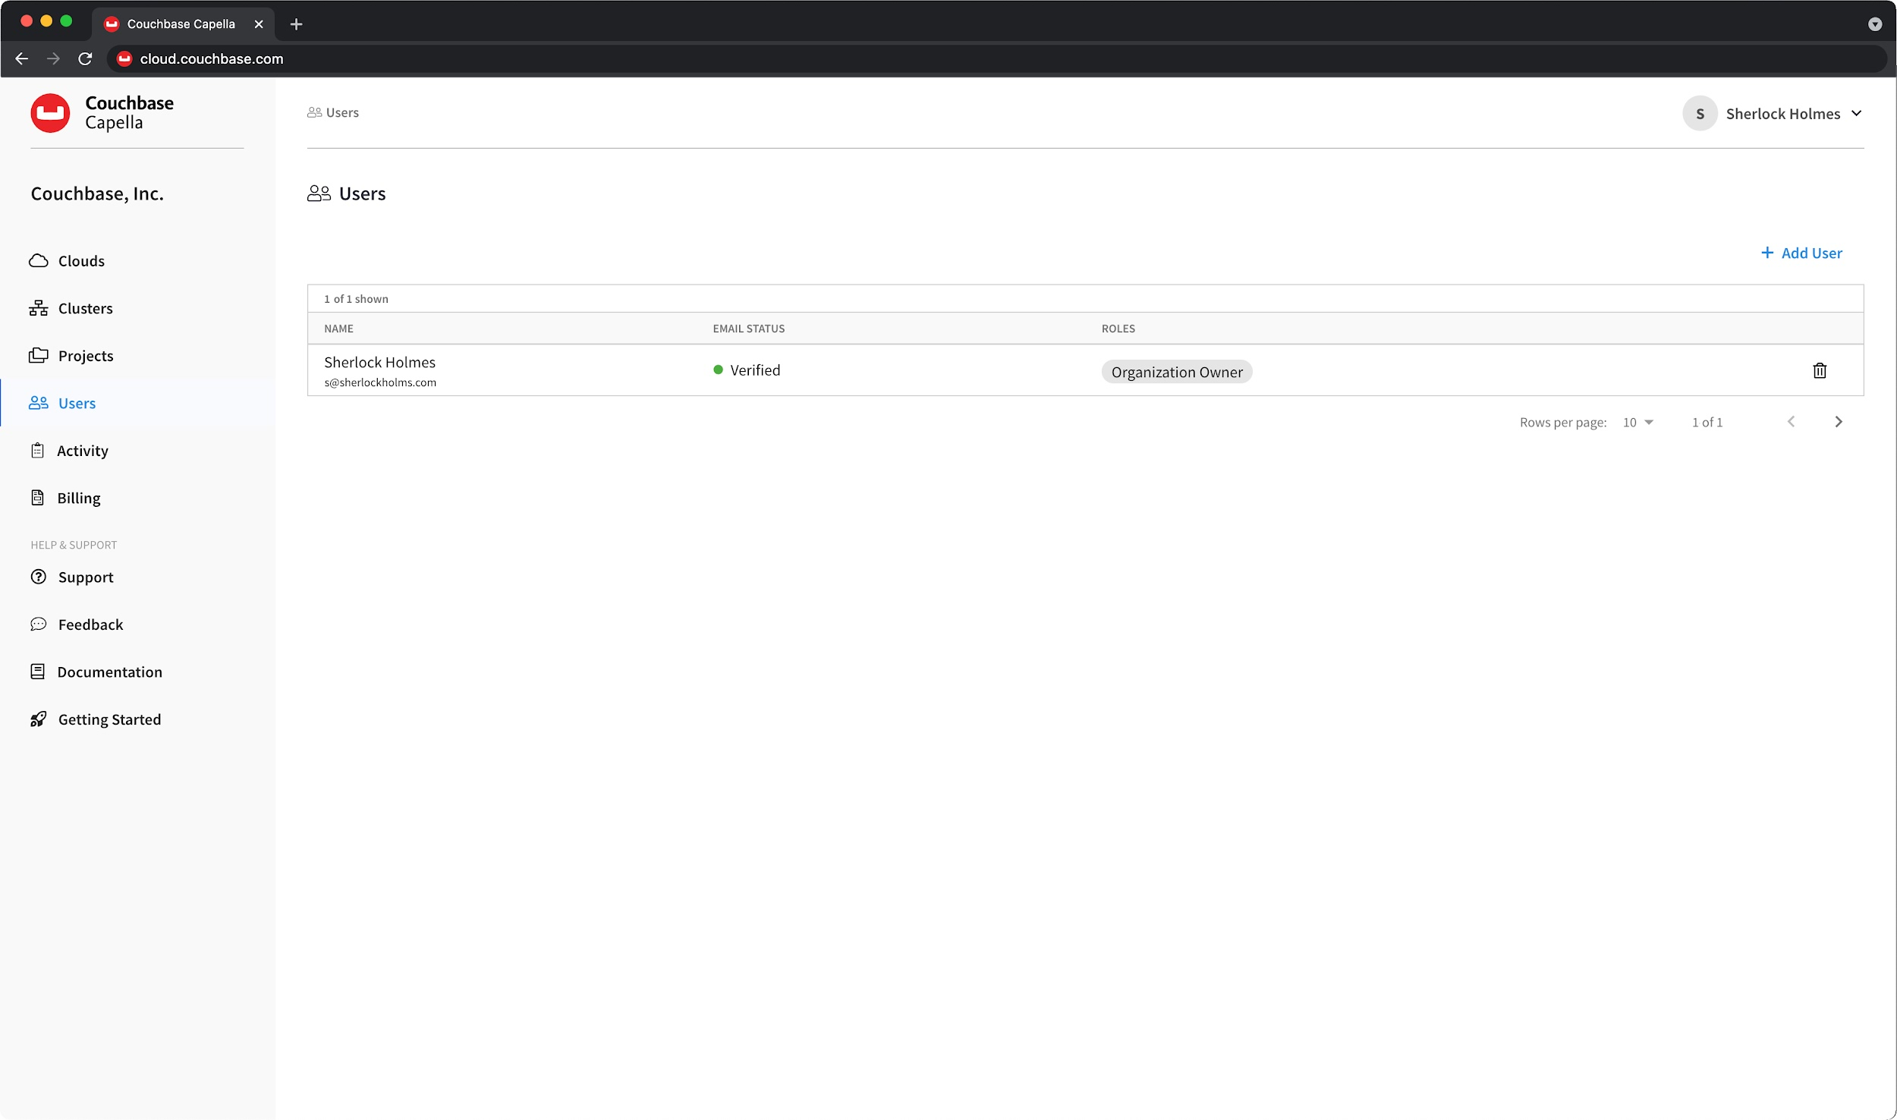

# 

# 

# Activity:

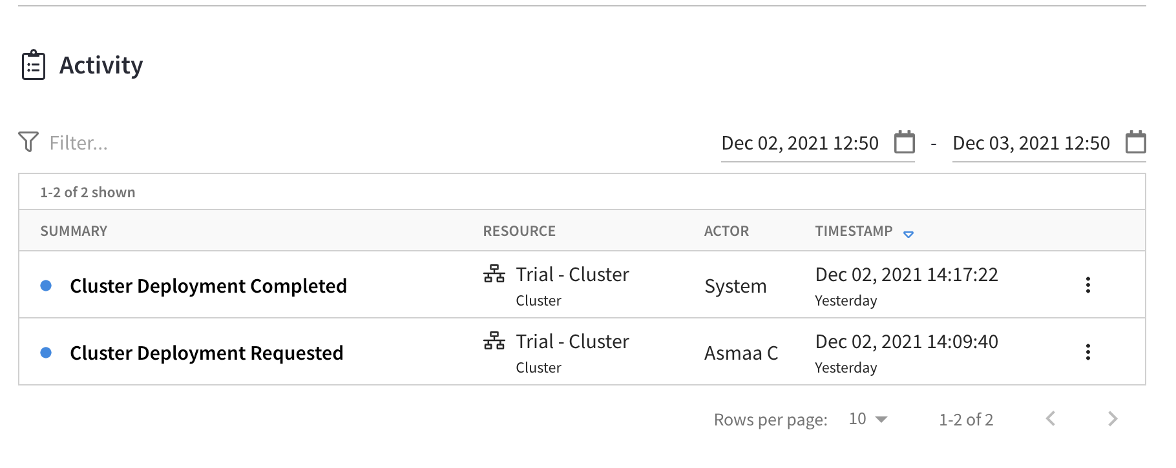

# Support:

All clusters in Couchbase Capella must have an associated *Support Plan*. There are multiple Support Plans to choose from, each of which can be selected on a *per cluster basis*.

During the process of deploying a cluster, you are required to select both a Support Plan and a Support Time Zone for the cluster. The Support Plan that you select determines both the hourly price that you will be [billed](https://docs.couchbase.com/cloud/billing/billing.html) for that cluster, as well as the [level of support](https://docs.couchbase.com/cloud/support/support.html#support-levels) that the cluster is entitled to. The [Support Time Zone](https://docs.couchbase.com/cloud/support/support.html#support-time-zones) that you select determines when the time window for human support begins and ends for clusters that aren’t on a Support Plan that comes with 24x7 support.

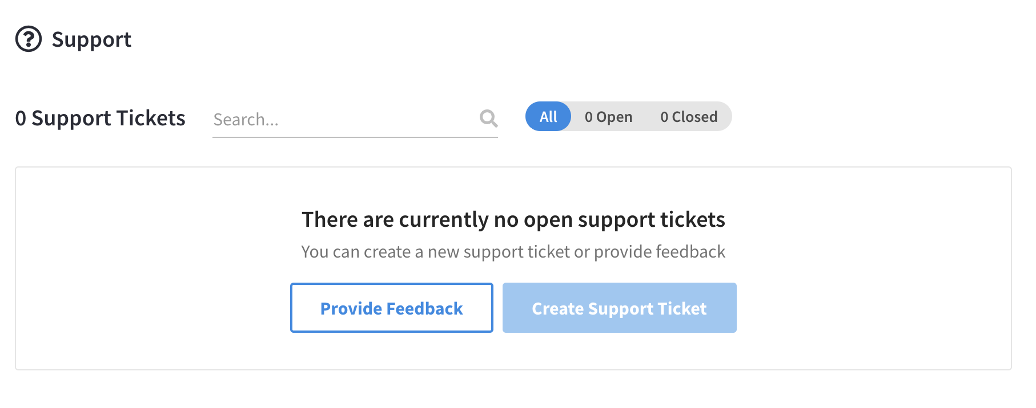

# Clusters Walkthrough:

As you can see in the screenshot below, it gives a high level overview of the cluster and services health as well as some metrics

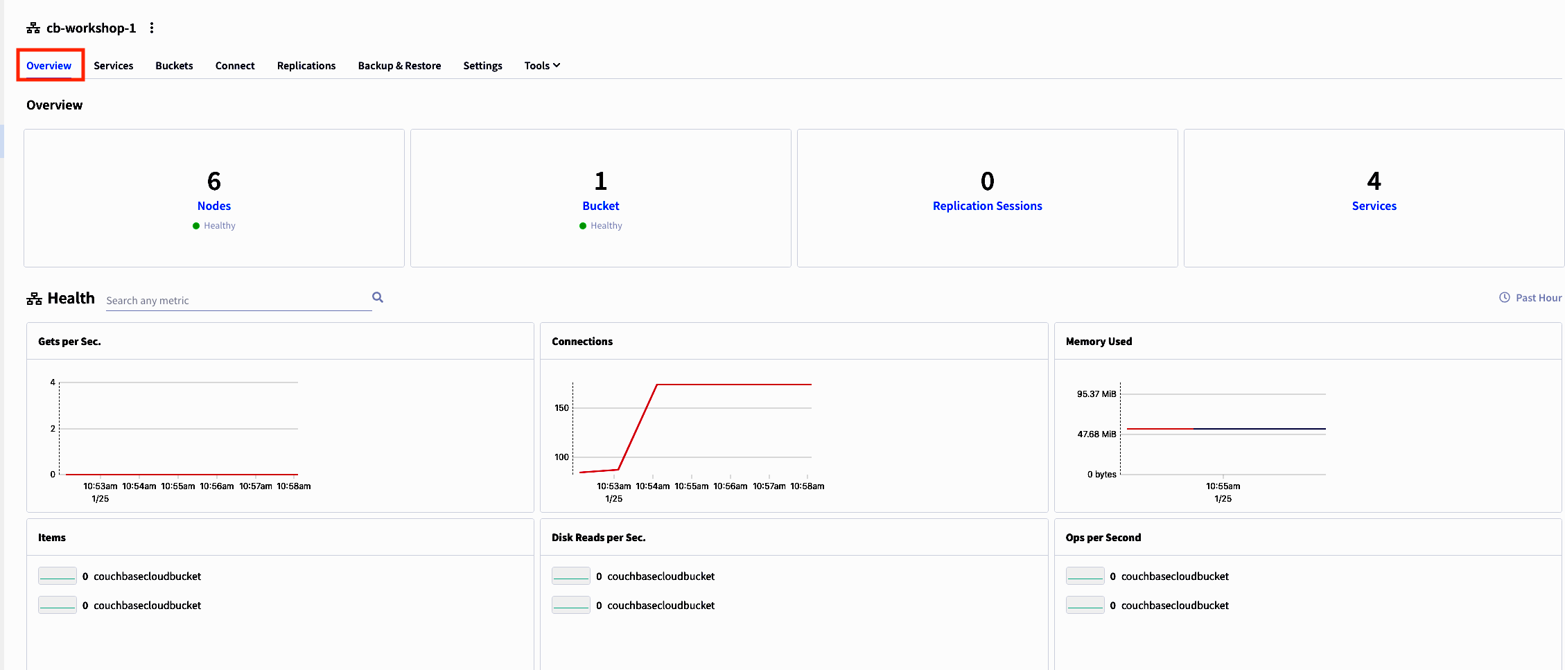

## Configuration:

The Configuration tab shows settings like services, nodes, compute, and disk type.

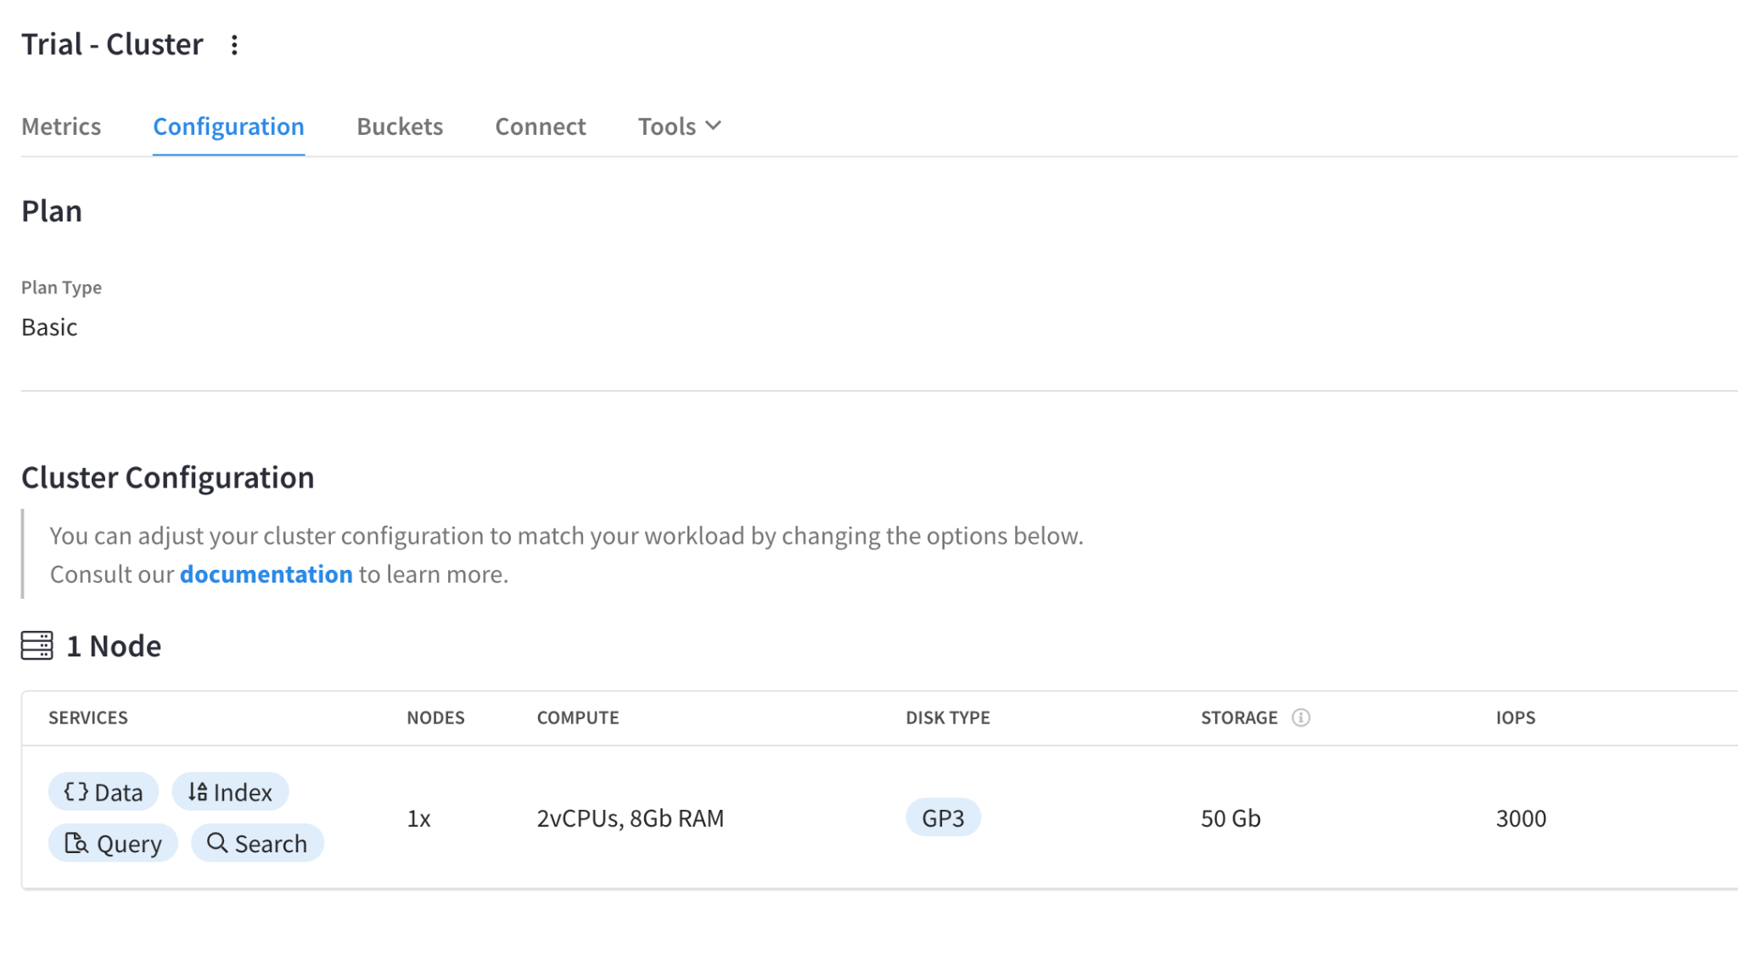

In a non-trial account, you can add and remove nodes, as well as easily make changes to hardware, memory, and storage. The ability to easily configure clusters makes it simple to scale horizontally and vertically.

Following any configuration changes, Capella automatically rebalances your data across nodes. No changes are needed on the application side. Also, services can be assigned per node, a feature we call Multi-Dimensional Scaling. For example, you may want compute-optimized hardware for one service and memory-optimized hardware for another. This helps you performance match your application’s needs to the database and its infrastructure. By more efficiently using your hardware, you improve performance while also bringing down TCO.

## 

## Buckets:

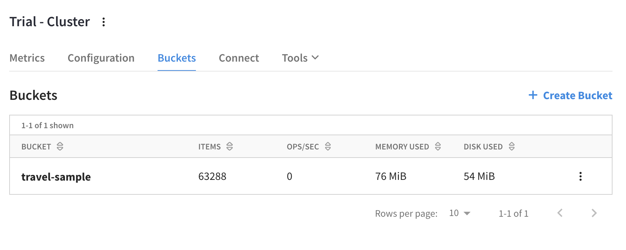

## Connect:

This is where we will find information to establish an external connection to your Capella cluster.

Listed in the Wide Area Network area, you will see your database endpoint. The endpoint in the screenshot below has been changed, so your endpoint will look a little different.

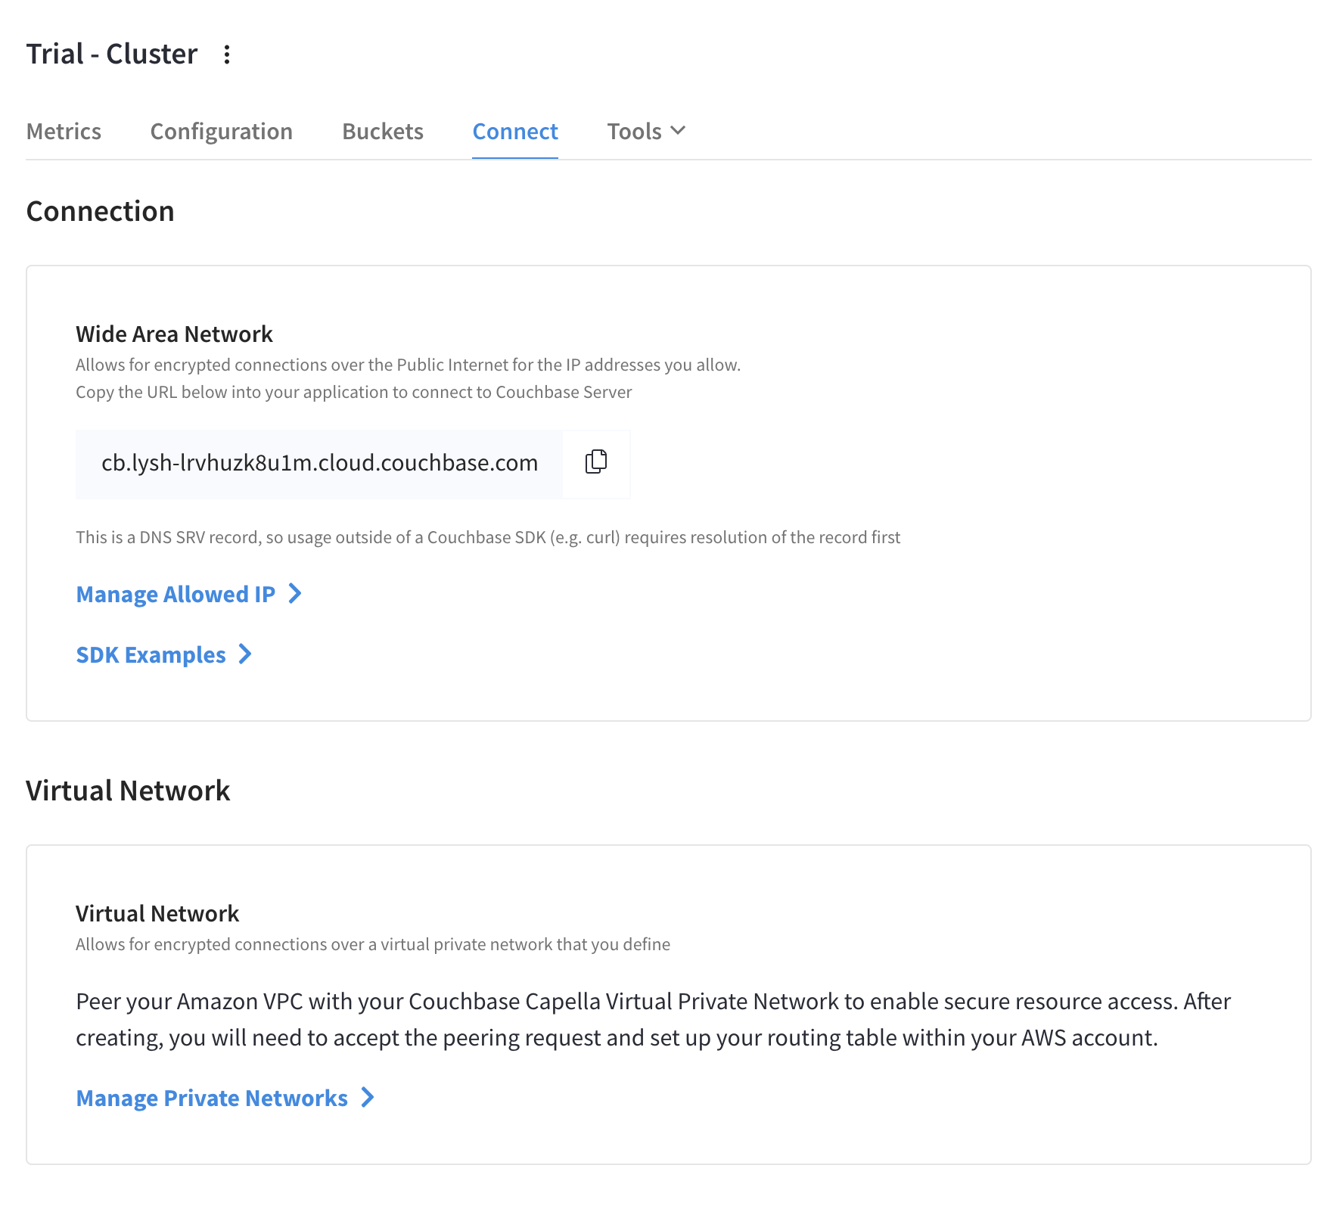

## SDK Examples:

Each of the supported Couchbase SDK languages is represented by a tab. Under each tab, a snippet of example code is provided. The example code is pre-populated with the cluster’s public endpoint, and with a few modifications, can quickly be used for connecting to the cluster.

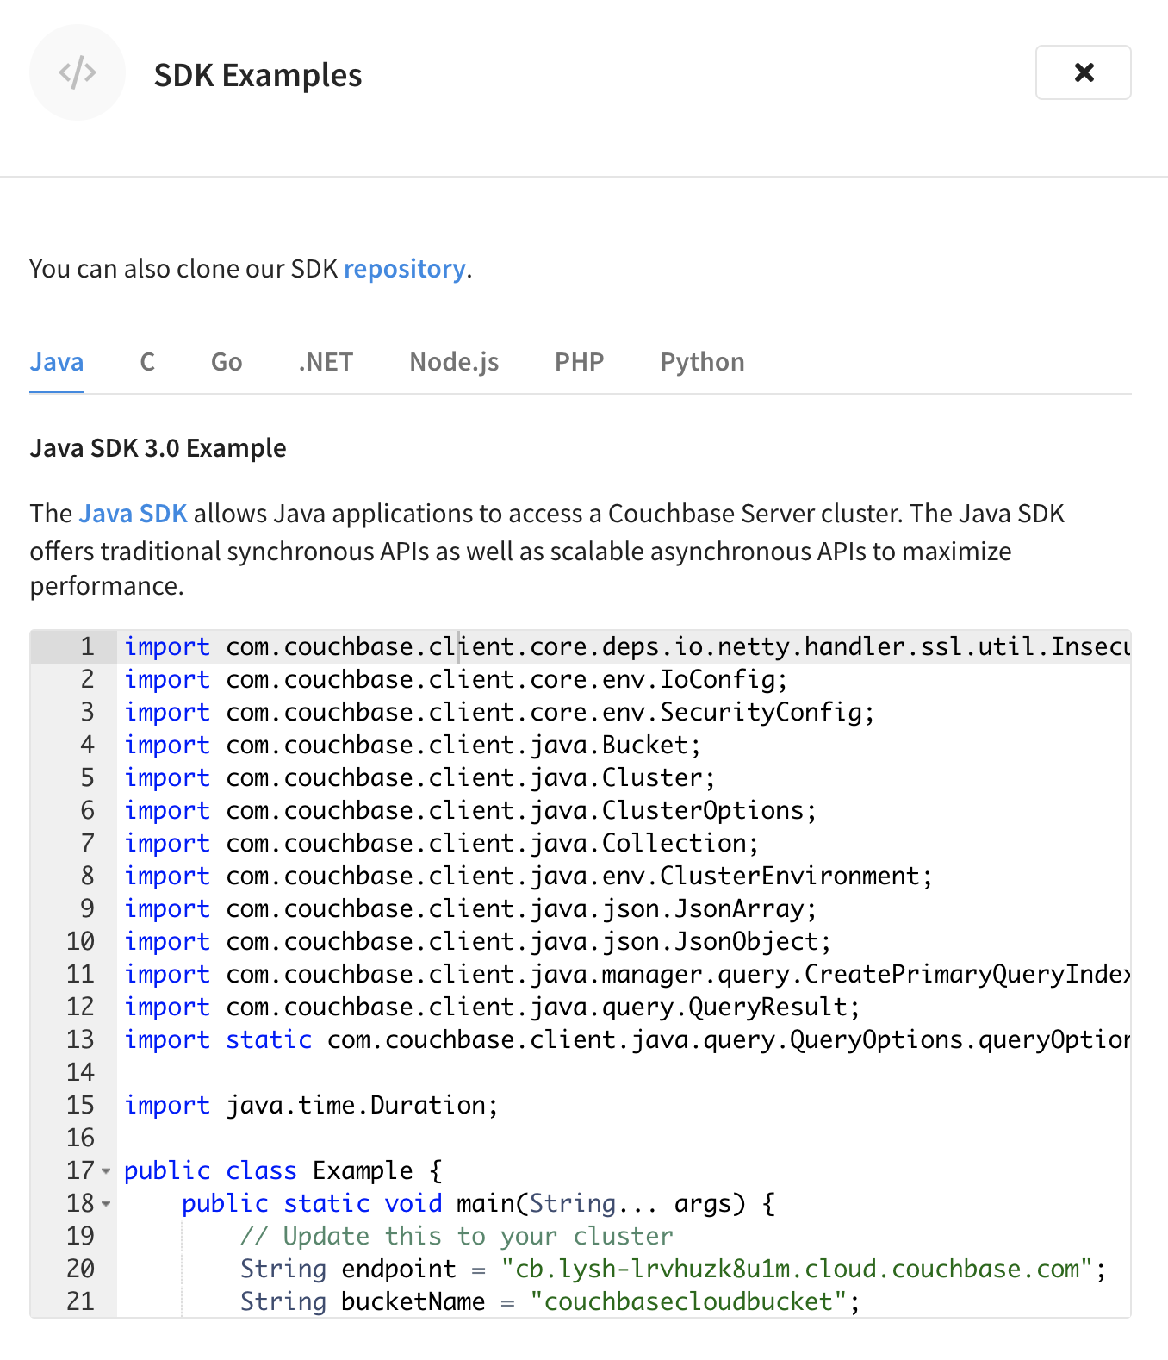

## Tools:

In the Tools section, this is where you can find all different ways of interacting with your data in the cluster. We will go through each item in the pulldown menu in details in the upcoming labs.

